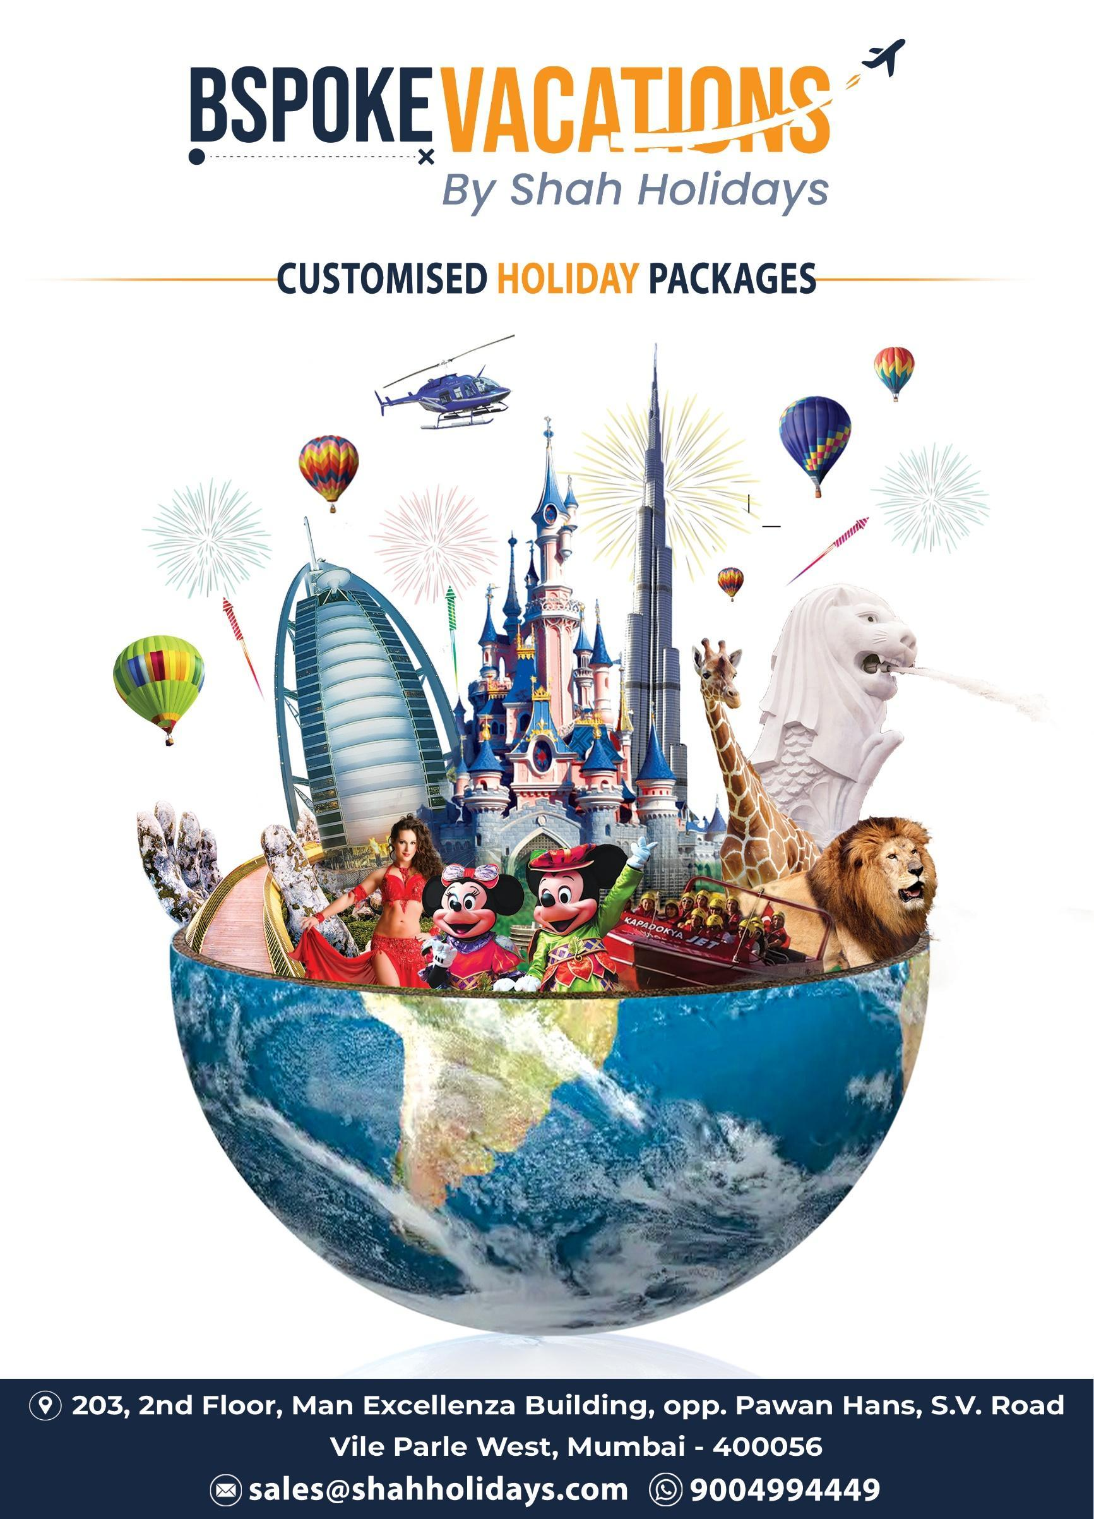

DISCOVER ALMATY

Tour Days: 05 NIGHTS/06 DAYS

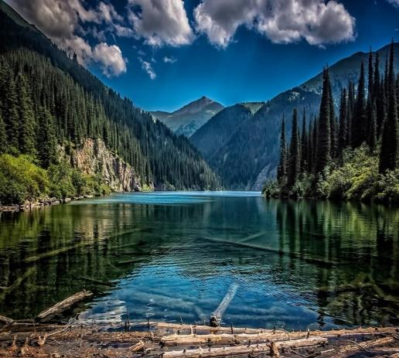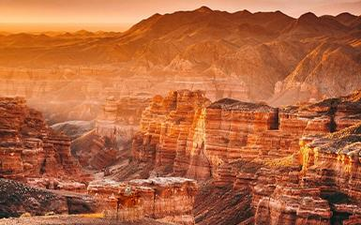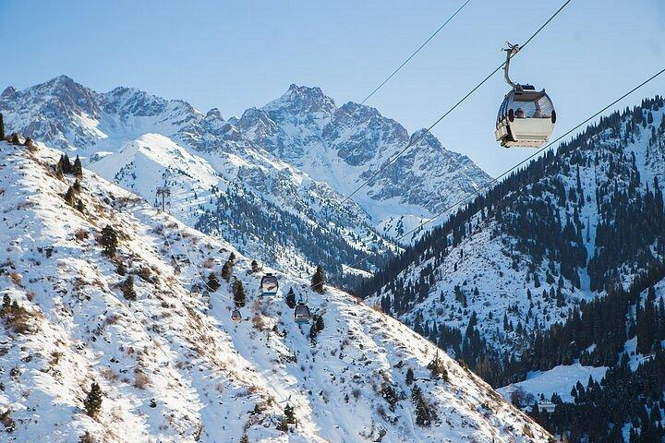

DAY 01: ARRIVAL ALMATY – ALMA ARASAN GORGE
Arrive at Almaty Airport, After Customs and Immigration Formalities Transfer to Hotel. (room check in at 15.00 hrs).
Arrive freshen up at hotel lobby and later proceed for Alma- Arasan Gorge. Alma-Arasan is a picturesque mountain gorge located in the southwest of Almaty at an altitude of 1780m on the northern slope of the Trans-Ili Alatau. The Prokhodnaya River flows through the gorge. The gorge is good for recreation in nature. You can have a picnic, enjoy the fresh mountain air and stunning views.
Later check in at hotel.
Evening Free for rest & personal activities.
Overnight at the hotel.
(Dinner)

DAY 02: ALMATY CITY TOUR WITH KOK TOBE CABLE CAR
Today after breakfast proceed for Almaty city tour. Today You will know more about history and development of the southern capital of Kazakhstan and see it's main attractions such as: The Central State Museum of the Republic of Kazakhstan, the Presidential Residence, the Republic Square and the Independence Monument, the Theater of Opera and Ballet named after Abai, Astana Square, Abai Square and the Palace of the Republic.
Later proceed for Amazing Kok-Tobe cable. Kok-Tobe is the highest TV tower in the world, if you count from the sea level. A special viewing platform located on the mountain will allow you to admire the magnificent panorama of the city, as well as you can stroll along the winding paths of Kok-Tobe Park and visit souvenir shops. Our guide will tell the meaning of souvenirs and help to buy the best one.Evening return back to the hotel. Overnight at the hotel.
(Breakfast + Dinner)

DAY 03: ALMATY – CHARYN CANYON
Today after breakfast start our tour in the beautiful canyon Charyn. Is situated in the territory of the Charyn National Park which was laid out with the purpose to preserve natural and geological objects. The National Park was founded on 23 February 2004. The Park territory is inhabited with a great number of rare and endangered animal species entered in the Red Book. In Sarytogai natural boundary of the Park territory, there are protected forests are growing with one of the most unique trees - Sogdian ash existed as far back as the Palaeogene epoch. The aspen grove is unique, the second analogue grove is found in North America. The aspen grove, a monument of nature is especially protected under aegis of UNESCO. Its age is about 5 million years.
Evening return back to hotel. Overnight at hotel.
(Breakfast + Dinner)

DAY 04: ALMATY – KOLSAI LAKE & KAINDY LAKE
Today after breakfast start our tour with Kolsai lake. Kolsay lakes are 3 lakes located 300 km from the city, at Kungey Alatau mountains. The lakes included to the list of the most beautiful natural places in Kazakhstan. The most popular and available lake - is first lake or Lower lake, at a Height of 1800 m above the sea level and has 2 km length and 800 m width.( Boating at own cost)
Later continue you tour with Kaindy lake. Lake Kaindy is a 400-meter-long lake located in Kazakhstan. The lake reaches depths of nearly 30 meters. It is located 129 kilometers east-southeast of the city of Almaty and is 2,000 meters above sea level. Evening return back to hotel.
Overnight at the hotel.
(Breakfast + Dinner)

DAY 05: MEDEU - SHYMBULAK BY CABLE CAR & RAKHAT CHOCOLATE FACTORY WITH GREEN BAZAAR -CITY TOUR.
Today after breakfast proceed to visit Shymbulak. proceed on an excursion to the beautiful mountain resort of shymbulak ski resort including gondola tickets to level 3 and services of our english-speaking guide. “shymbulak ski resort” is in the beautiful zailiyskiy alatau mountain at 2260 m above sea level. The ski slopes are served by gondola cars from “medeu” to the base of shymbulak, 2260 m above sea level. This gondola is the world’s third-longest gondola with a length of 4.5 km.
Later proceed for Rakhat Chocolate Factory Shop and Green Bazar.At our last destinations you will have a great opportunity to buy local sweets from Rakhat Chocolate Factory and dry fruits at cheap rates and some souvenirs from Green Bazar.Later Continue our Almaty city tour. So, the next locations that we will visit, where you will get acquainted with the old part of the city and see the Vernensky buildings of the 19th century as well: Park of 28 Panfilov Guardsmen, Ascension Cathedral, House of Officers, Museum of Folk Musical Instruments, Memorial of Glory.
Evening return back to the hotel. Overnight at the hotel.
(Breakfast + Dinner)

DAY 06: ALMATY – HOME DESTIANTION
Today after breakfast check out from hotel.
Later transfer to the Airport to board your flight for Home country.
(Breakfast)

TOUR ENDS WITH SWEET MEMORIES

-: DELUXE HOTEL: -

:-TOUR COST INCLUDES:-
- Twin/Triple sharing accommodation in Deluxe hotels.
- Return Airport transfers by Private Vehicle.
- Breakfasts in a hotel & Dinners in Indian Restaurant.
- Extensive sightseeing in private vehicle with driver cum English guide.
- Almaty Visa (Currently Free on arrival for 14 days stay for Indian Citizens)
- Exciting Guided Mountain tour to Medeo & Shymbulak by cable car
- Charyn Canyon tour
- Kolsay lakes
- Kaindy lake
- Alma Arasan Gorge
- Tour to Kok Tobe by cable car
- 2 Water Bottles Per Pax Per Day.
- All entrances tickets.
- GST

- : TOUR COST DOES NOT INCLUDE: -
- International airfare and airport Taxes.
- Lunches.
- 5% TCS ( Tax Collected at Source)
- Personal Expenses Such As Room Service, Laundry Charges, Phone Calls, Boating,/Water Sports, Porterage, Excess Luggage Charges in Airlines, Tips, Insurance & All Other Items Of Personal Nature & Also Food & Drinks Not Forming Part Of Group Menu.
- Any Other Item Which Is Not Specifically Included In The “Tour Cost Includes”

-:PLEASE NOTE:-
- Bspoke vacations Shall Not Accept Any Liability Or Responsibility For Any Delay In Flights Or Change In Schedule By The Airline And Any Situations Arising Out Of The Same.
- The cost is based on Minimum 02/04/06 adults traveling together in the tour.
- Any Damages Caused To The Hotel Rooms/Coach During Your Stay, Shall Be Payable By The Passengers. Bspoke vacations Will Not Be Liable For The Same.
- Bspoke vacations Shall Not Accept Any Liability Or Responsibility For Any Damages, Loss, Injury, Accident, Death, Delay, Breakdown Or Irregularity Which May Occur In Carrying Out Of The Tour Arrangement.
- Bspoke vacations Management Reserves The Right To Claim Any Additional Expenses Due To Delay Or Changes In Train, Plane, Bus, Ship Or Other Services, Weather Conditions, Strikes, War, Quarantine And Any Other Cause Whatsoever And All Such Loss Or Expenses Must Be Borne By The Passengers.
- We Reserve The Right To Amend, Alter, Vary Or Withdraw Any Particular Departure, Excursion Advertised Or Substitute A Hotel Of Similar Class If Deemed Advisable Or Necessary.
- For The Convenience Of Our Passengers, Bspoke vacations Will Sometimes Amend The Itinerary; However All The Other Services Will Remain The Same.
- Bspoke vacations Will Not Be Liable In Any Loss Of Baggage By The Airline.
- The Tour Cost Is Combination Of All The Arrangement And Hence Cannot Be Calculated On Individual Service Basis. Tour Cost Is One Component And Not Calculated On Individually.
- Single Room Supplement Charges Will Be Applicable In Case Any Of The Guest Cancel The Reservations Sharing Room Together.

- Please Refer To The Booking Form For Detailed ‘Terms And Conditions’.
:-CANCELLATION DUE TO BORDER CLOSURE:
- In Case We Are Unable To Operate A Tour Due To Border Closure, Bspoke vacations Will Refund The Deposit Amount After Deducting The Administrative Fees Of ₹ 10,000/- Per Person.
- In The Event That the Entire Tour Cost Has Been Paid By You And We In Turn Have Paid Our Overseas Tour Operators, After Which The Tour Gets Cancelled Due To Border Closure, Then It Is Possible That We Are Not Able To Get The Amount Back, Then We Will Try And Get The Refund Or A Credit Note For A Later Travel Date.
- Any Loss Due To The Exchange Rate Will Affect The Refund Amount.

CANCELLATION CHARGES OF THE TOUR COST
PER HEAD (CANCELLATION WILL BE ACCEPTED IN WRITING ONLY)

A. | Deposit to Book the tour (Nonrefundable) | ₹ 20,000/- Per Person
B | Full Payment to be made | 60 days prior to departure
 | Cancellation Rules:- ( calculated as % of tour cost)
A. | Before 60-45 Days prior to the scheduled departure of the tour | 20%
B . | Between 45 to 30 Days prior to the scheduled departure of the tour | 40 %
C. | Between 30 to 15 days prior to the Scheduled departure of the tour | 75 %
D. | Under 15 Days prior to the scheduled departure of the tour | 100 %

The above cancellation policy is only for the land portion (Hotel /Meals /Sightseeing).
The cancellation charges will be charged separately as per Airlines policy.

------------------------XXXXXXXXXXXXXXXXXXXXXX-----------------------

